Water Cycle Webquest

In early 2014, NASA will launch an important satellite that will enable us to learn more about our home planet. The Global Precipitation Measurement mission (GPM), will provide us with the most sophisticated and accurate measurements of global precipitation ever! In this webquest, you will learn a little about this mission, and then will focus on the Earth’s water cycle.

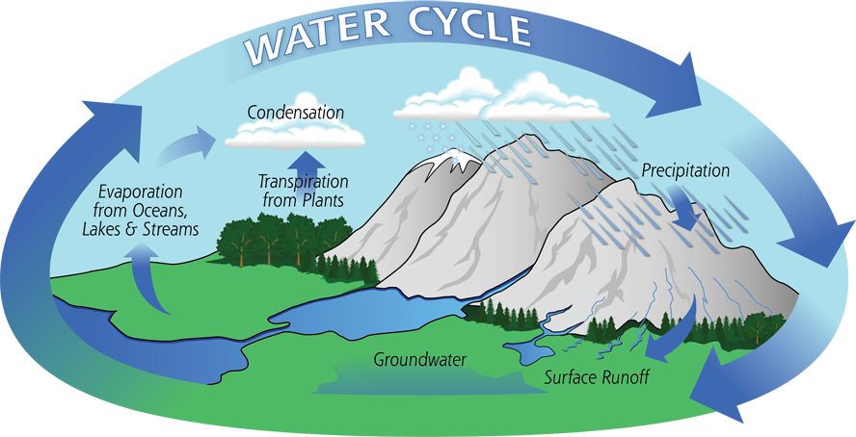

Precipitation is a vital component of how water moves through Earth’s water cycle, connecting the ocean, land and atmosphere. Water evaporates from the surface of the land and oceans, rises and cools, condenses into rain or snow, and falls again to the surface as precipitation. The water falling on land collects in rivers and lakes, soil, and porous layers of rock, and much of it flows back into the oceans. The cycling of water in and out of the atmosphere is a significant aspect of the weather patterns on Earth.

Scientists study how precipitation moves around the world, how much it rains in local areas, and what kind of rain or snow falls - is it heavy rain from a storm or a just a drizzle? They use what they learn to understand how precipitation impacts streams and rivers, water flowing across the surface of the ground, and groundwater. GPM's frequent and detailed measurements are part of what scientists use to make models of the Earth's water cycle so they can see how it is changing.

The Global Precipitation Measurement (GPM) is an international satellite mission that will provide next-generation observations of rain and snow worldwide every three hours.(to Jacob- from the lithograph). Here is an introductory video to give you a sense of what it will do and why the science behind the mission is so important:
http://pmm.nasa.gov/education/videos/gpm-freshwater-connection

In order to understand precipitation, we need to step back and take a look at the bigger picture. Let’s follow a molecule of water as it makes its way through the water cycle in this short animation:
http://pmm.nasa.gov/education/videos/tour-water-cycle

Scan the article titled “The Water Cycle” in the following link:
http://earthobservatory.nasa.gov/Features/Water/

Now that you have the feel for how water is able to move through the land, the air, and the oceans, let’s learn more about how it is able to distribute both water and heat as it moves through the water cycle:
http://pmm.nasa.gov/education/videos/earths-water-cycle

The ocean is vital for moving both water and heat energy through the water cycle. Here you will see actual NASA data sets that have been put into animations and positioned on a globe to help you visualize how solar energy drives the water cycle. Consider the fact that the ocean heats up more slowly than the land- as you can see in the first and second visualization- but it also retains the heat that it absorbs from the sun much longer. In the final visualization, you will see how the sea surface temperature changes over a four-year period.
http://pmm.nasa.gov/education/videos/water-cycle-heating-ocean

The next website will focus on how evaporation and winds combine to move water from oceans to land. It shows how Earth’s systems interact with each other with actual data:
http://pmm.nasa.gov/education/videos/water-cycle-steaming-air

We know that almost everything needs freshwater to survive. Did you also know that we use freshwater to generate electricity, make computer chips, and to produce most of the items we use on a daily basis? Go to this site and poke around to learn more about what freshwater is used for in our everyday lives. You can find out how much water is used in your state as well as find out more about the water in the area that you live in. This data is only available for the United States on this website:
http://www.epa.gov/WaterSense/our_water/water_use_today.html

To finish off this portion of the webquest, sit back and enjoy this video that sums up many of the content you focused on in this section:
http://gpm.nasa.gov/education/videos/water-water-everywhere

